Personnes à appeler pour porter l'Automate

Individuals to call upon to carry The Human Robot

1/ Procedures to carry The Human Robot

Depending on your strength (as to not drop The Human Robot) you can use the following method :
- 2 People : Hold The Human Robot under the neck and feet
- 4 People : Hold The Human Robot under the arms and hold the ankles.(Easiest)

Transport The Human Robot horizontaly up to the front of the audience.

Should his hat fall off during the move, kindly put it back firmly on his head. Thank you!
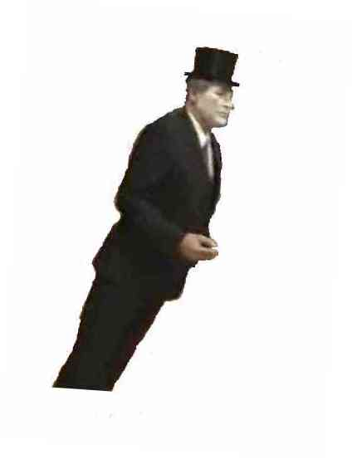
2/ Once The Human Robot is placed vertically (upright and standing) be
Maximum lean ratio!
Anymore and it’ll be impossible to prevent him from falling.
VERY CAREFUL ! Chances are that The Human Robot might lose his
balance, hence, please place yourselves to the north,south,east and
west as to be able to hold him back should he start falling.

As to verify the stiffness of The Human Robot, please try to fold his
arms. By default, they should go back to their original placement

3/ Read the following text ( in red ) to the audience

- Robot or Human ?

-Observe the fixed stare….. would a human be capable of such a difficult feat ?

-Will you be able to make him laugh or tickle him ?

-Be assured, you will not succeed no matter how much you try.

- Then, it must be a ………..

During the show, please to not use flash photography,
especially aimed at the Human Robot eyes.

4/ Once The Human Robot is stable, please start the music.

It’s SHOWTIME !

